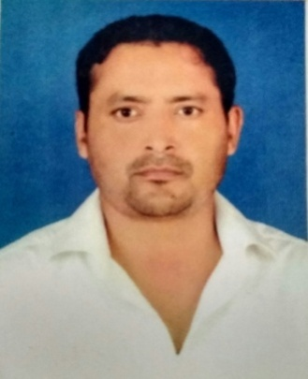

**Dr*.* SHIV PRAKASH MISHRA**

**Assistant Professor (Guest)**

**Teaching and Research Experience:**

11 Years of teaching and Research Experience.

**Research Interest:**

Phosphorus Compounds as Poly- (Phosphoric acid/Phosphates such as Graham’s Salt & Phosphazenes) under Polymer Chemistry

**Work Experience:**

* Working as an **Assistant Professor (Guest)** in Department of Physics and Electronics, Dr. Rammanohar Lohia Avadh University.
* **Senior Assistant Professor** in N.N.P.G. College Nawabganj, Gonda,(U.P.) for 9 years.
* **Assistant Professor** Chemistry(B.Tech.),N.N.T.C.Nawabganj, Gonda, for 1 year.

**No. of research papers in journals: 04**

**Participation in Conference/Seminars: 02**

**Participation in Workshops: 01**