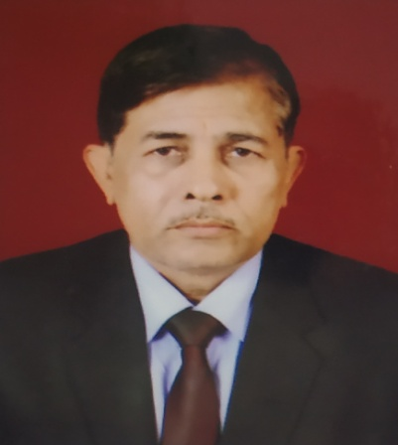

**Prof. Raj Kumar**

**Dean**

**Teaching and Research Experience :**

32 Years of Teaching and Research experience and 10 years as a Professor

**Research Interest:**

* Electronic circuit simulation.
* Reversible logic technology.

**Recent Interest:-**

* Electronic circuit simulation

**Distinguished and Notable Awards / Membership:**

* **Integrated Scholarship** from 1974 to 1976.
* **Silver Medal** for obtaining First Position in M.Sc. Previous examination 1981, Allahabad University, Allahabad (U.P.), India.
* **Ward Vidyant Memorial Gold Medal** for securing highest marks and First position in M.Sc. final examination 1982, Allahabad University, Allahabad (U.P.), India.
* Qualified National Entrance Test 1983 held by Council of Scientific and Industrial Research (C.S.I.R.), New Delhi.
* “**Junior Research Fellowship**” by C.S.I.R. New Delhi India from January 1984 to December 1985.
* “**Senior Research Fellowship”** by C.S.I.R. New Delhi India from January 1986 to December1986.
* Founder member of International Academy of Physical Sciences, Allahabad.
* **Life member** of Vigyan Parisad Prayag, Allahabad. 15.

**Work Experience**:

.

1. Lal Bahadur Shastri P.G. College, Gonda, **Lecturer** selected from Higher Education Commission, Allahabad, January 16, 1987 to April 30,1991

2. Dr. Rammanohar Lohia Avadh University, Faizabad, **Lecturer** in the department of Physics and Electronics,from may 01,1991 to January16,1995

3. Dr. Rammanohar Lohia Avadh University, Faizabad, **Senior Lecturer** in the department of Physics and Electronics, from January16, 1995 to January16, 2000.

4. Dr. Rammanohar Lohia Avadh University, Faizabad, **Associate Professor** in the department of Physics and Electronics, from January16, 2000 to 2008.

5. Dr. Rammanohar Lohia Avadh University, Faizabad, presently working as a **Professor** in the department of Physics and Electronics from January 01 Jan 2009 to till date.

**Citation / h /i-10 indexes:**

**Citations :62**

**h-index :05**

**i10-index :01**

**No. of research papers in journals: 63**

**No. of research papers in Conference:18**

**Participation in Conference/Seminars:16**

**Participation in Workshops:**

**No. of Books Edited/Published:**

**No. of Produced Ph.D.:13**