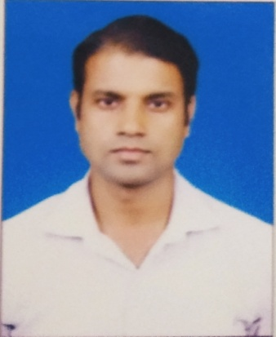

**Dr. Ashwini Kumar**

**Assistant Professor (Guest)**

**Teaching and Research Experience:**

3 years of Teaching and 7 years of Research Experience.

**Research Interest:**

* Heavy ion Collision Experiments
* High energy Physics
* Material Science

**Recent Interest:**

* Quantum Espresso
* X-Crysden
* Vesta
* Avogadro

**Distinguished and Notable Awards/ Membership:**

* **UGC (BHU) Fellowship**
* [**CSIR-SRF Fellowship**](mailto:Fellowship@Rs)
* :**VATAT Fellowship**
* Member of Departmental Anti-Plagiarism Committee, Department of Physics and Electronics, Dr. Ram Manohar Lohia Avadh University Ayodhya.

**Work Experience :**

Dr. Ram Manohar Lohia Avadh University, Faizabad (From 30 August 2017 till now ).

Dr. Ram Manohar Lohia Avadh University, Faizabad 2015.

**No. of research papers in journals: 11**

**No. of research papers in Conference**

**International:03**

**National:05**

**Participation in Conference/Seminars:14**

**Participation in Workshops: 04**